TOWN OF LEE

CHRISTMAS LIGHTING

CONTEST

2020 Winners

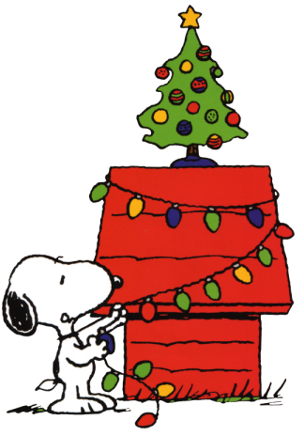

Sheri Cole 1ST PRIZE - $50.00
Cassey & Matthew Andrews 2ND PRIZE - $30.00
James & Tammy Voss 3RD PRIZE - $20.00

Honorable Mentions:
Eric & Monique Welch Peter Savino
Thomas Grisham Erik Wolfer (Muffin Man)
Erika Robinson Irineo Alegre

THANKS TO ALL WHO SHINED THE LIGHTS FOR LEE-YOU’VE BROUGHT JOY TO LOTS OF FACES (BOTH YOUNG AND OLD)

TOWN OF LEE

2020

CHRISTMAS LIGHTING

CONTEST

CONGRATULATIONS

Cassey & Matthew Andrews

2nd PRIZE

TOWN OF LEE

2020

CHRISTMAS LIGHTING

CONTEST

CONGRATULATIONS

Sheri Cole

1st PRIZE

TOWN OF LEE

2020

CHRISTMAS LIGHTING

CONTEST

CONGRATULATIONS

James & Tammy Voss

3rd PRIZE

TOWN OF LEE

2020

CHRISTMAS LIGHTING

CONTEST

CONGRATULATIONS

Eric & Monique Welch

HONORABLE MENTION

TOWN OF LEE

2020

CHRISTMAS LIGHTING

CONTEST

CONGRATULATIONS

Peter Savino

HONORABLE MENTION

TOWN OF LEE

2020

CHRISTMAS LIGHTING

CONTEST

CONGRATULATIONS

Thomas Grisham

HONORABLE MENTION

TOWN OF LEE

2020

CHRISTMAS LIGHTING

CONTEST

CONGRATULATIONS

Erik Wolfer (Muffin Man)

HONORABLE MENTION

TOWN OF LEE

2020

CHRISTMAS LIGHTING

CONTEST

CONGRATULATIONS

Erika Robinson

HONORABLE MENTION

TOWN OF LEE

2020

CHRISTMAS LIGHTING

CONTEST

CONGRATULATIONS

Irineo Alegre

HONORABLE MENTION

