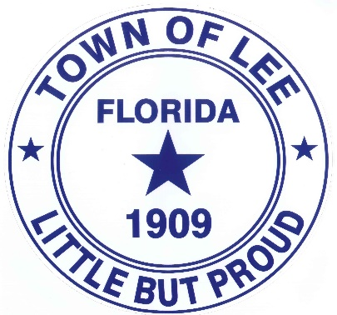
TOWN OF LEE CLEANUP
The Town of Lee is looking into providing a one-time pickup of large appliances and furniture to assist our residents in disposing of these items. This will be for residents that are currently on the Town’s water and/or wastewater service.
A pickup date will be determined by the response the Town receives from residents for this assistance and advertised on the Town’s web page and facebook page at a future date. Please contact Lee Town Hall at 850-971-5867 if you are interested in a scheduled pickup or if any questions.
We will not be picking up household hazardous waste (HHW) or any of the following items:
- Automotive parts
- Oils
- Construction materials
- Commercial appliances
- Paints
- Medicine
- Fluorescent lights
- Cardboard

